*<GAS SNIFFER>*

SAFETY – IT’S A CHOICE, NOT A CHANCE

Version *<1.0>*

TABLE OF CONTENTS

1. INTRODUCTION 3

2. WHAT’S IN THE BOX 3

3. CONFIGURATION 4

3.1 4

3.2 4

3.3 5

3.4 6

3.5 7

# INTRODUCTION

The GAS SNIFFER is a wireless gas diffusion monitor that measures the PPM of flammable gas in kitchen with a view to detecting gas leakage for creating a safe and risk free environment. With its wireless connectivity feature, the GAS SNIFFER can deliver real-time gas PPM over the internet through WiFi. Clients can monitor the live condition of their kitchen through app or website from anywhere in the world. In case of hazardous conditions, not only the device alerts the client by an audible alarm but also the client receives an SMS alert on their phones. Customers has the flexibility to adjust the resolution (Alarm Trigger Level) of the device as per their need.

# WHAT’S IN THE BOX

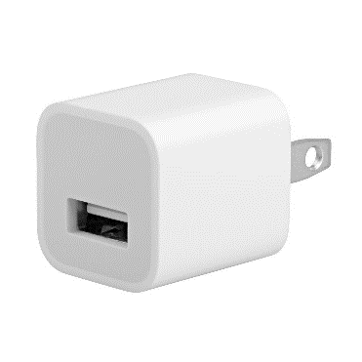

USB Adapter USB Cable (For Power)

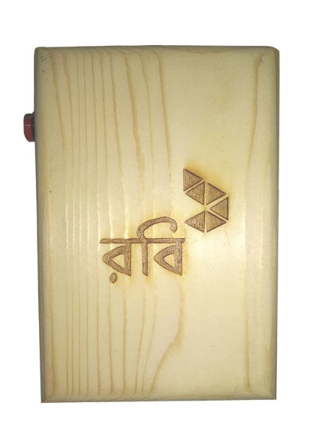

Gas Sniffer

# CONFIGURATION

3.1 Connect one end of the USB cable into the GAS SNIFFER and the other end into the power adapter. Plug the power adapter into a nearby outlet. The device will beep twice when it gets power.

3.2 Turn on the WiFi of your mobile and connect to “Kitchen Guard V1.0.0”. “123456789” is the default password. Input the password and press connect.

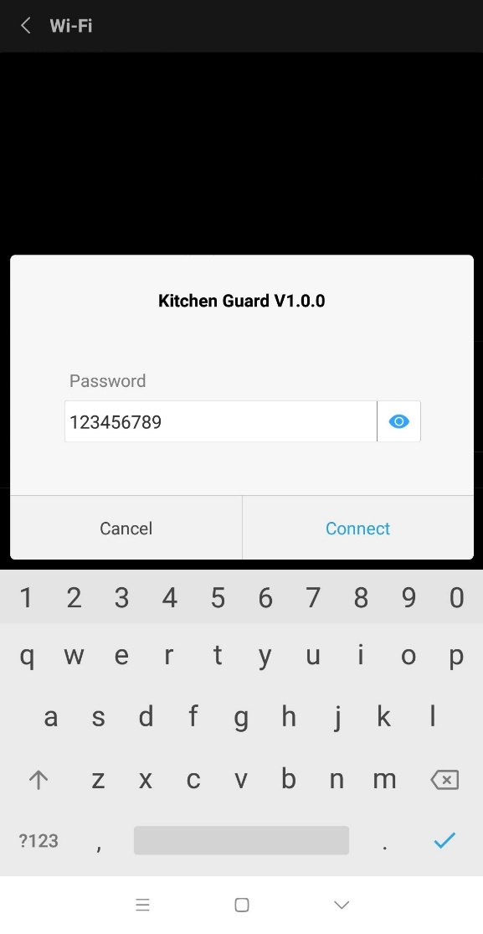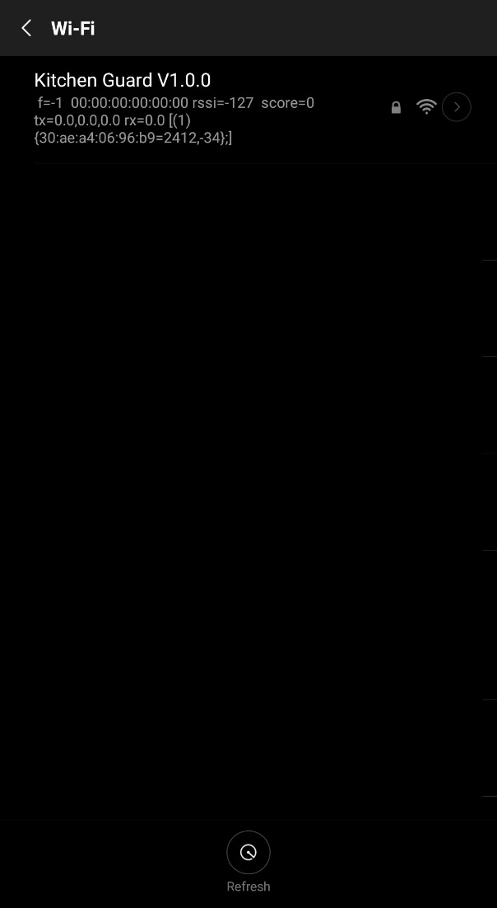

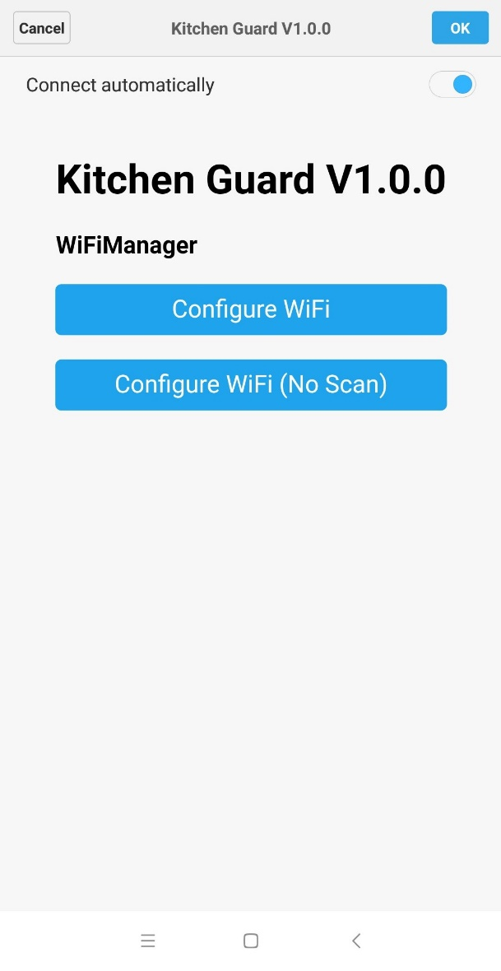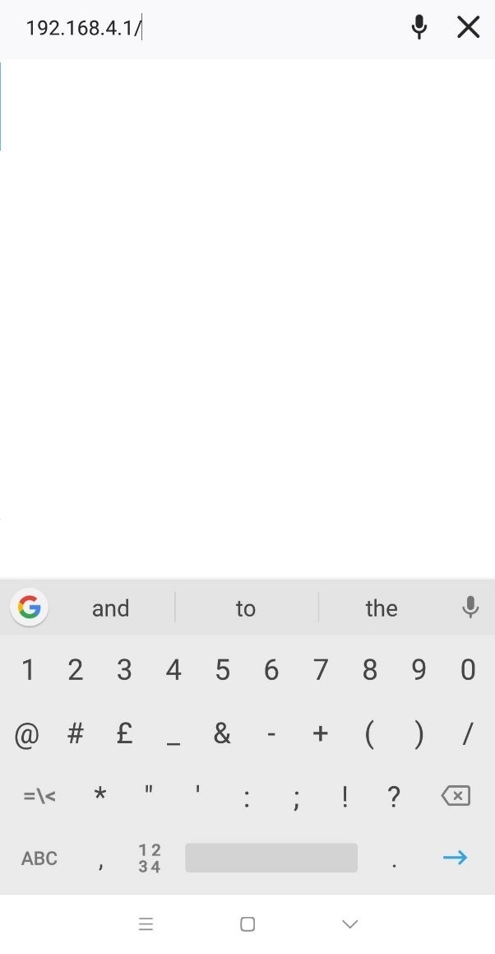3.3 After successful connection, open the web browser and type “192.168.4.1” in the address bar and press enter.

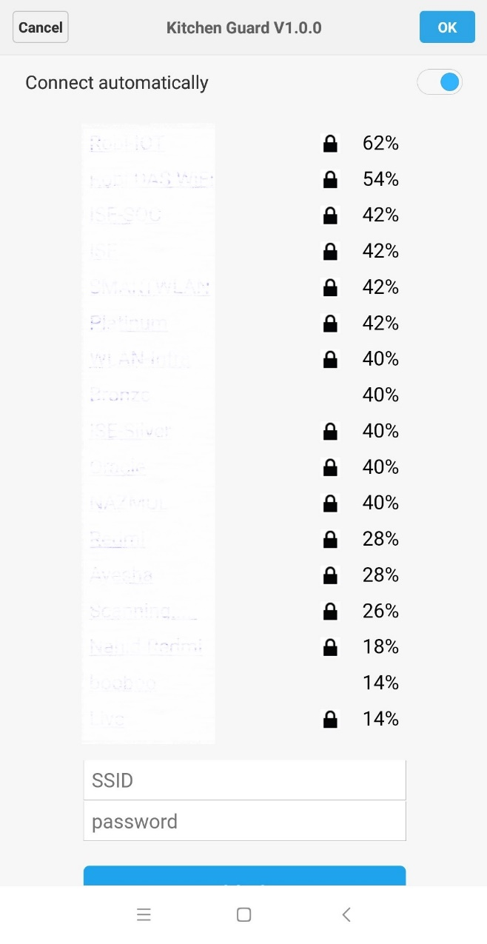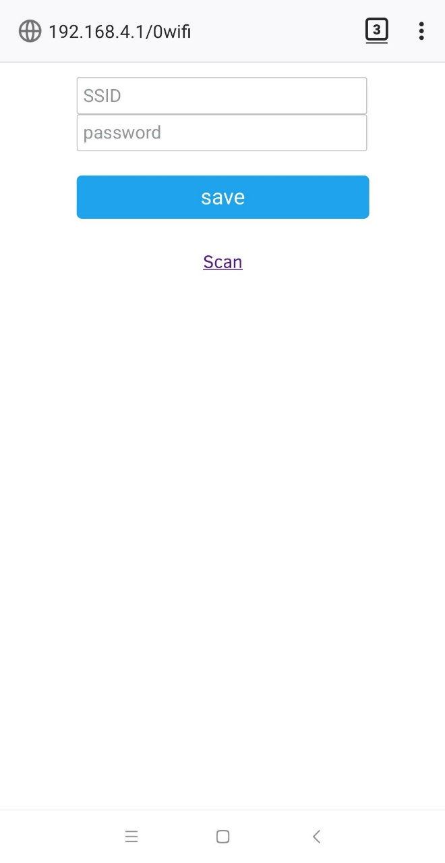3.4 Select **Configure WiFi (No Scan)** to manually type the desired SSID and password to connect to the desired access point. Else, select **Configure WiFi** to scan for available WiFi networks. The device scan and view the available WiFi networks nearby.

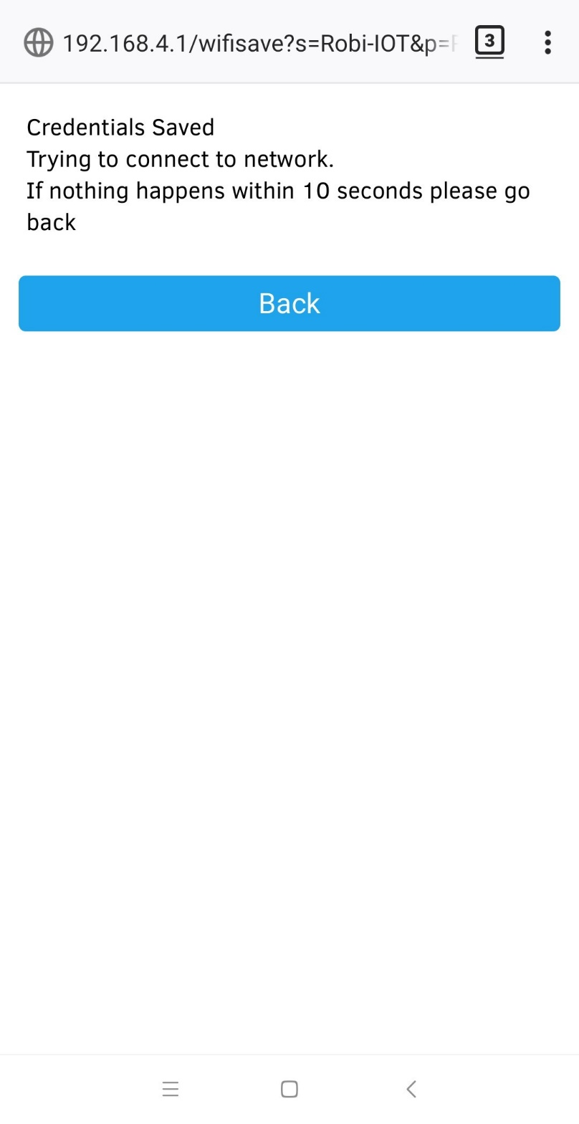3.5 Type/Select the desired WiFi network, provide the password and click save. In case of successful connection, the device will beep 3 times. On the other hand, if no beep is heard within 10 seconds, click **Back** and try again.

3.6